Child Art Study- Collection & Analysis By Debra Troyanos 9/4/12
I chose to research child art that portrays a storytelling image. These stories reveal a lot about the child, their culture, and their environmental surrounding. The level of detail is often astounding on many of them. Most convey the world in a positive light. That could be that these images were selected for the International Collection of Child Art, through the University of Illinois. I became so enchanted with the child art on this website, it was difficult to narrow down the images to any less than these below, for consideration and analysis. Below please find the storytelling images that intrigued me.
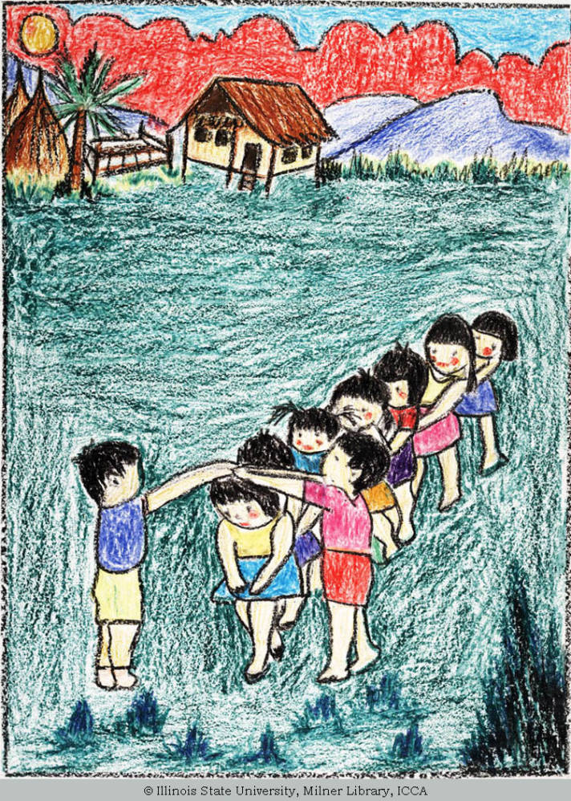
Title "Go Under The Bridge" Artist Gender Boy
Artist Age 14
Location Thailand
Date Created 1983 Material/Technique crayon
multi-colored drawing
Measurements 69.9 cm x 51.1 cm Artist Comments It is played by small children everywhere-I love this game.
This drawing was obviously made by a more mature artist, due to the excellent portrayal of perspective with the children shown on the bottom of the image, playing a game at recess that must have been common in the culture of Thailand. Objects in the distance are denoted by placing them toward the top of the page, showing an awareness of foreground, middle ground and background. Nice textures are shown in the figures hair, the grass and the thatched roof.

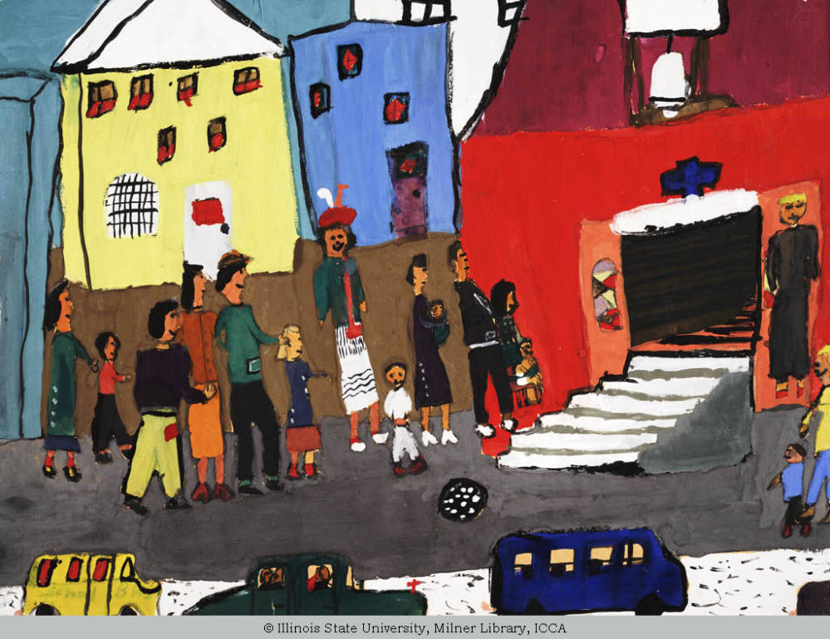
Title When My Family Goes to Church
Artist Gender Girl
Artist Age 9
Location Louisville, Kentucky, United States
Date Created 1960 Material/Technique water-based painting
Measurements 45.7 cm x 61.0 cm
This artist depicts an important part of her culture, telling the story of her family entering church. The urban environment is shown, but the people are larger in perspective to the vehicles. However, great attention to texture and detail is given in the treatment of the clothing, the architecture, and the windows.
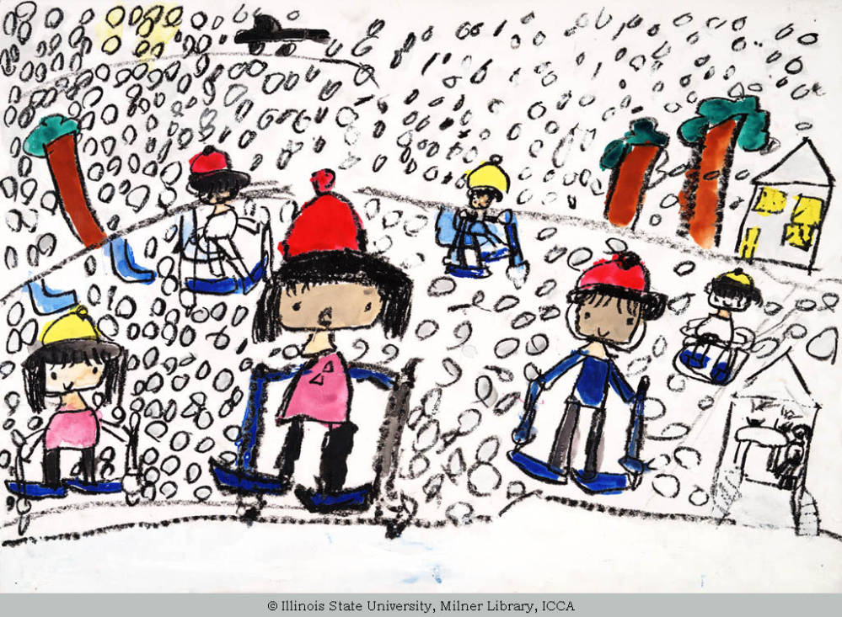

Title When I Went Skiing
Artist Gender Girl
Artist Age 6
Location Japan
Date Created 1989 Material/Technique multi-colored drawing
Measurements 38 cm x 54.7 cm
This young artist shows a happy moment she remembers when she went skiing. Great care went into creating every single snow flake, which must have taken great patience and time. An effort was made to place the horizon line higher on the picture plane in order to depict depth with the building and trees smaller in the distance. This is quite an achievement for a six year old.
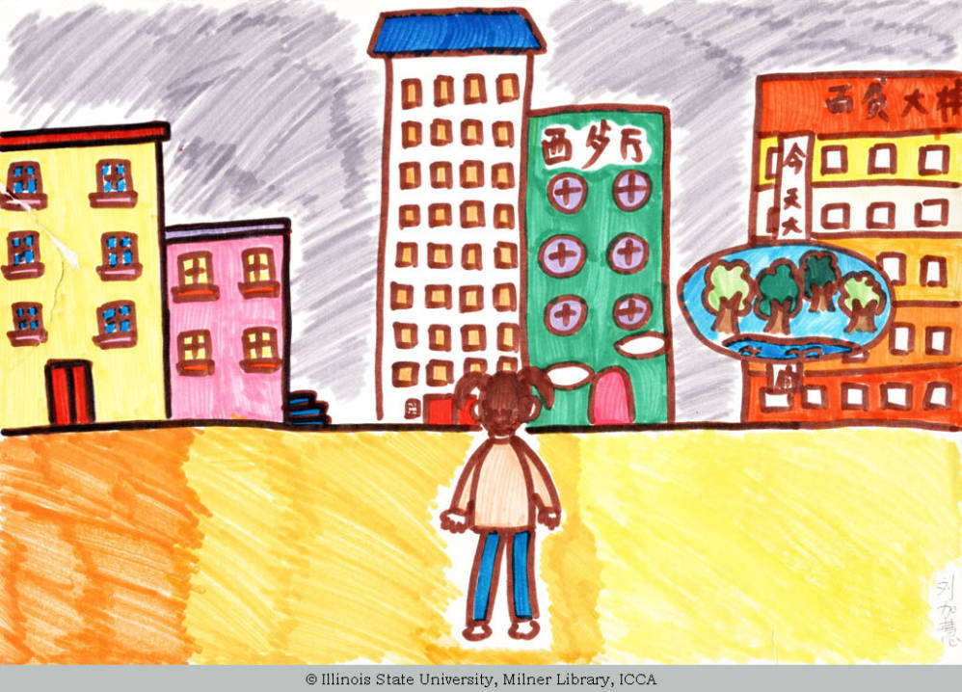
Title When Trees Become History
Artist Gender
Girl Age 11
Location Beijing, China
Date Created 2003 Material/Technique felt tip
Measurements 26.5 cm x 39 cm
This work seems benign until you read the jarring title, and realize the poignant political and social statement the young artist is making about her concerns over trees disappearing in the future. It is an interesting choice to have the figure facing the other way, drawing the viewer in to see the world through the child’s eyes. An effort was made to make different windows and details in each building of this future urban environment.

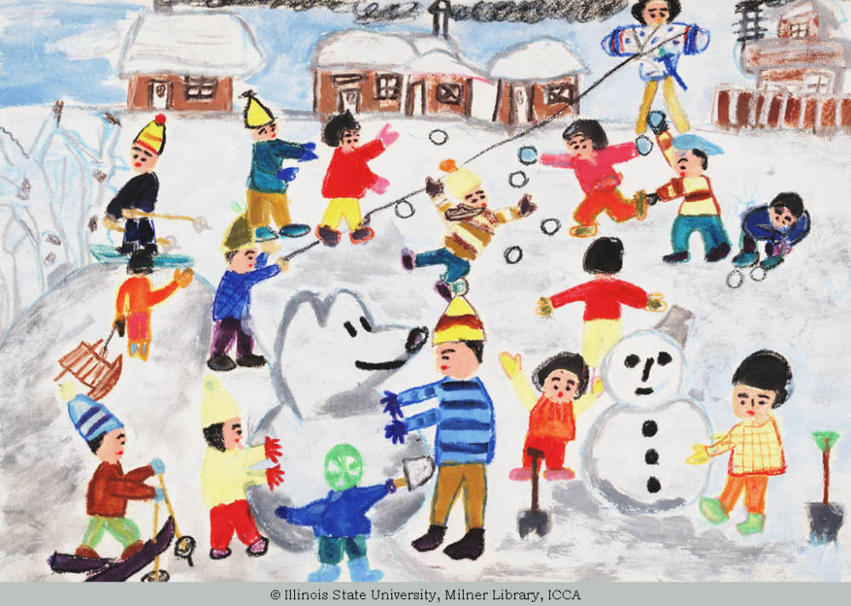
Title Winter Fun
Artist Gender Boy
Artist Age 7
Location Asahigawa, Japan
Date Created 1969 Material/Technique water-based painting
Measurements 38.1 cm x 53.3 cm
This interesting and delightful painting shows spatial relationships and overlapping beyond the typical 7 year old artist. I think showing action and games are a favorite subject for boys to choose. This one is busy and colorful, with a lot going on, yet the placement of the arms and legs of the figures lead your eye all around the image. Grey was used to depict the snow in shadow, which was also an artistically mature decision. Extraordinary detail on the patterns of the clothing and snow on the roofs of the homes in the distance are also extremely well done.

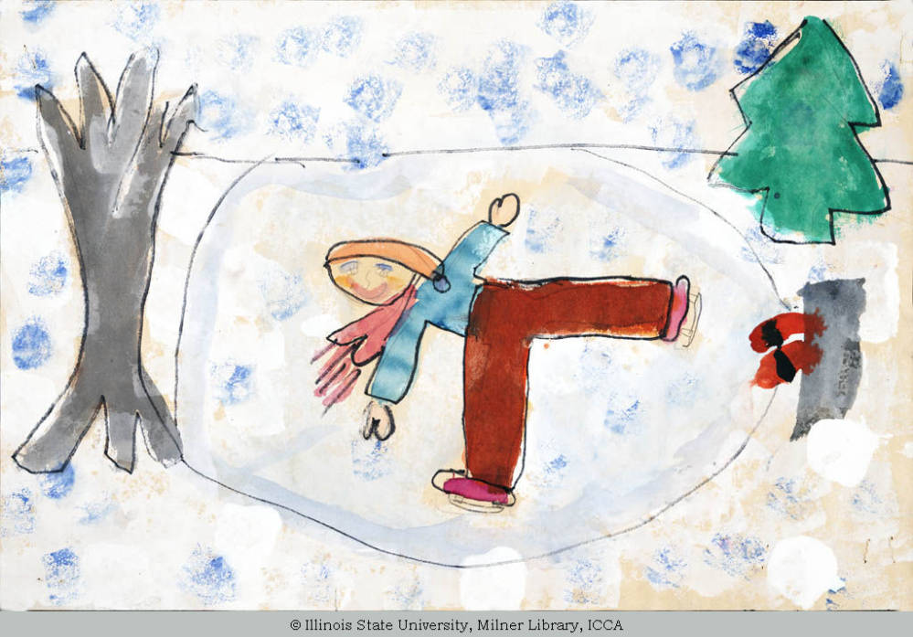
Title Winter Time
Artist Gender Girl
Artist Age 10
Location Garfield Heights, Ohio, United States
Date Created 1982 Material/Technique painting
Measurements 30.5 cm x 46.0 cm
Compared to the previous painting, this snow image is created by a female artist, who is three years older. These shadows are conveyed with a blue sponge. In this case the girl figure is skating alone, in contrast to the busy, crowded playspace of the boys in the previous image. A nice attempt was made to show the movement of the scarf as the figure spins on the ice. The perspective is shown in the tilted up viewpoint of the pond, while the trees are shown from a side view, which is common for an artist of this age group.
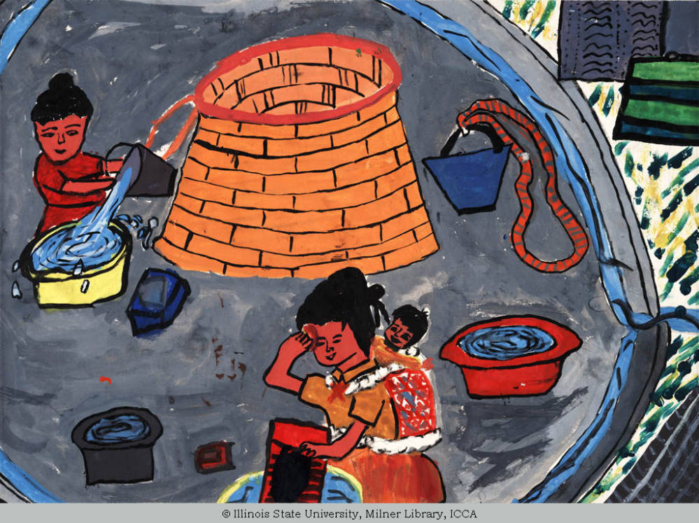
Title Working
Artist Gender Boy
Artist Age 10
Location Taiwan
Date Created 1973 Material/Technique multi-colored drawing
Measurements 28.0 cm x 37 cm
This young artist has created a storytelling image of women of his culture at work, perhaps doing laundry. A happy little baby is depicted on the mother’s back, and the mother wipes her brow. Again, as in the pond above, the viewpoint is tilted upward to show the floor. Excellent effort was made in the textures and in making the water look realistic.

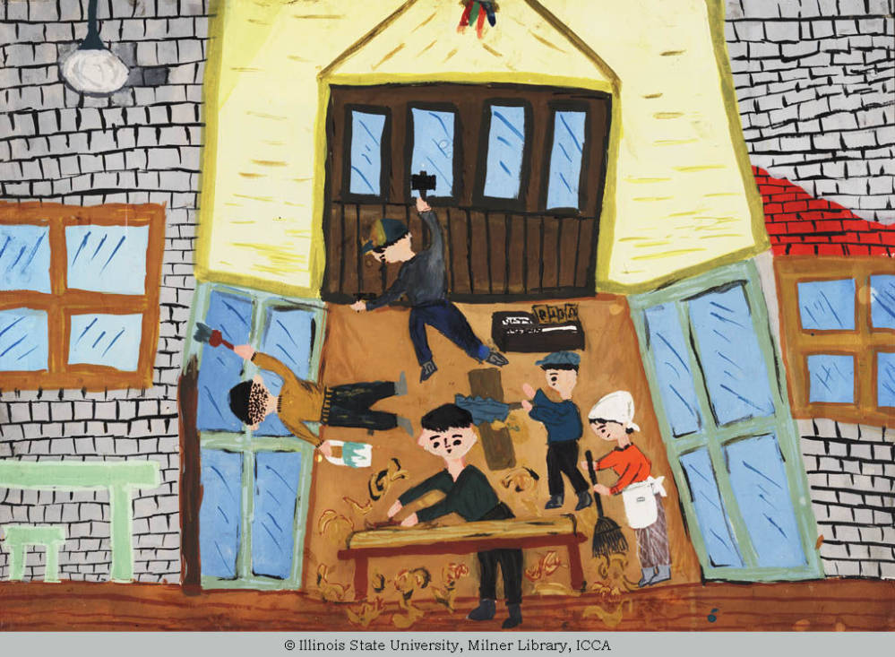
Title Workers Cleaning Up
Artist Gender Girl
Artist Age 9
Location Asahigawa, Japan
Date Created 1969 Material/Technique water-based painting
Measurements 29.9 cm x 45.1 cm
This image was painstakingly created to show individual bricks, wood shavings, and all of the workers on a job site. Compared with the women’s work in the image above, this work depicts men in a shop with a woman assistant. This artist found a charming way to organize the space from the side, and top view, in order to show all the figures in their jobs in the same room at the same time.
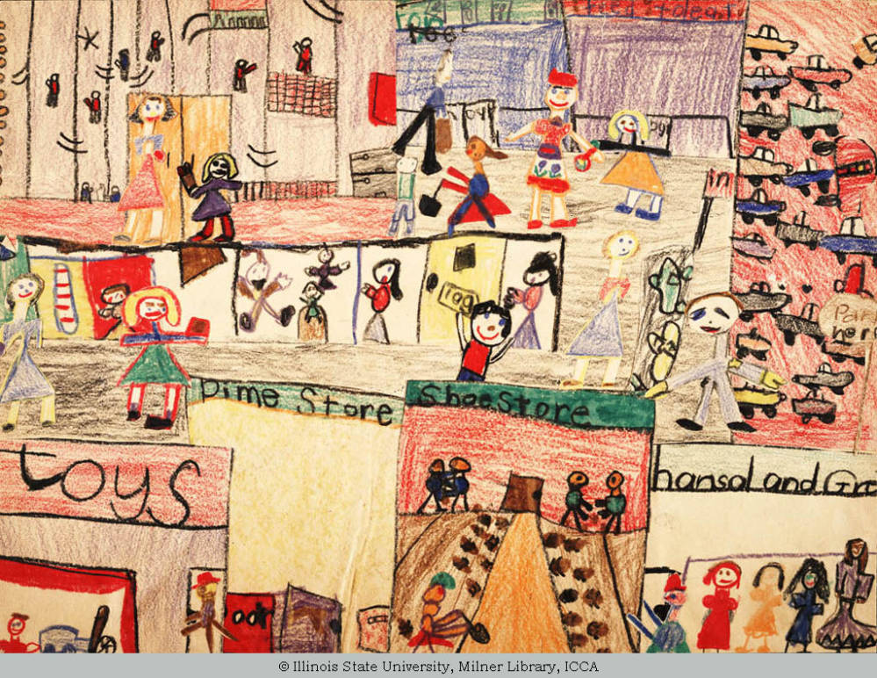
Title Woodmar Shopping Center in Hammond
Artist Gender multiple artists
Artist Age 7
Location Hammond, Indiana, United States
Date Created 1960 Material/Technique multi-colored drawing
collage
The artist organized space in this charming work which shows a mall, with all the various people, stores, and activities going on at one time. This was an effective way to tell the many stories that would have existed at the same time frame. Thus this artist was able to capture so much in her story and freeze time. Obviously, she is an American child, with her thoughts on consumerism already at age 7, as is common to our suburban middle-class culture.
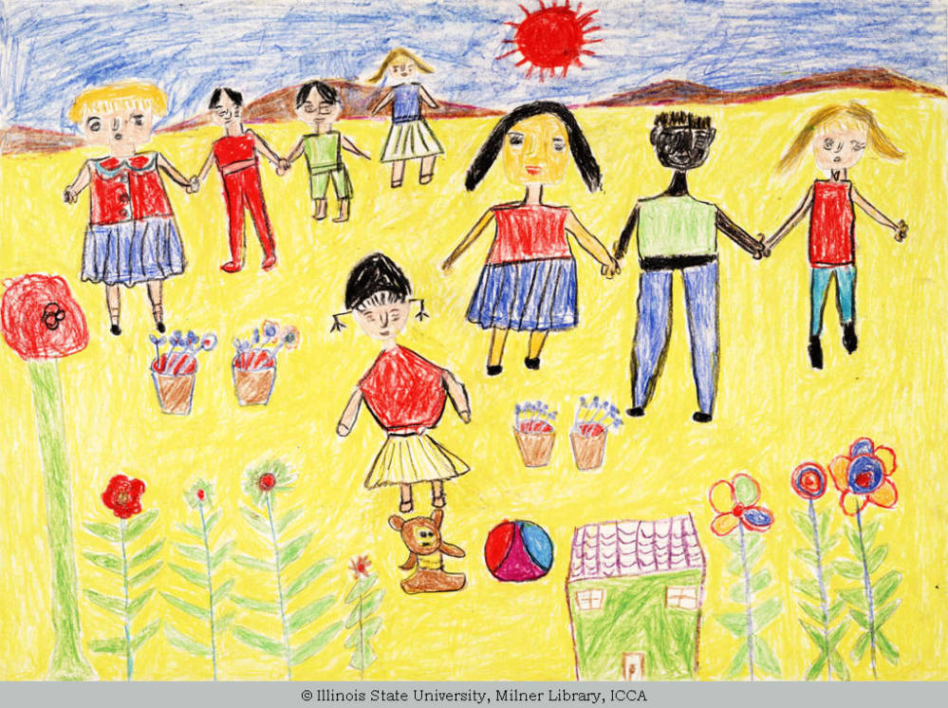
Title World Peace
Artist Gender Girl
Artist Age 10
Location Taiwan
Date Created 1973 Material/Technique multi-colored drawing
Measurements 39.0 cm x 54 cm
This beautiful and happy image shows an effort by the artist to show a diverse and peaceful world. The house and flowers are at the baseline, yet the figures are placed further back, with mountains in the distance. The people hold hands. It is an interesting choice that the artist choice to make the ground yellow, rather than green, since this color palette lends the sunny positive outlook to the image.

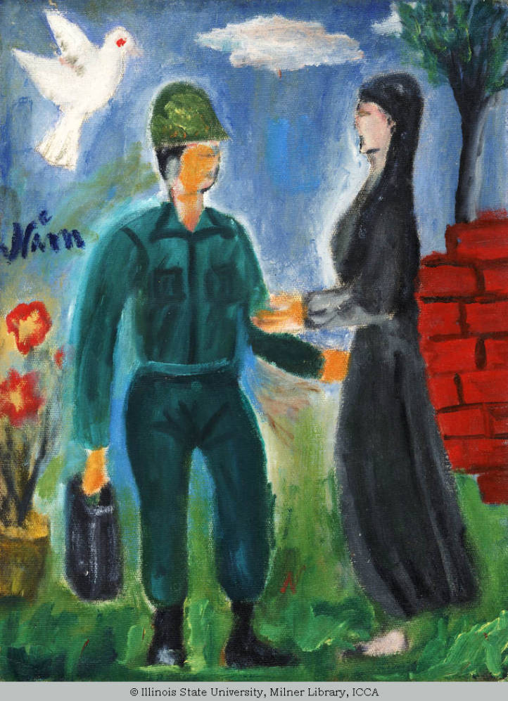
Title You have returned
Artist Gender Boy
Artist Age 12
Location Vietnam
Date Created 1972 Material/Technique oil painting
Measurements 40.0 cm x 30.5 cm
This painting tells an emotional image of a soldier returning home to a waiting woman, who is perhaps his wife, or love, or even mother. A white dove is shown, which shows the use of symbolism. This is a more unusual subject matter, especially for a male child, who often times will depict war images in a less peaceful light. It may be a cultural influence of hope for the missing soldier to come home to his waiting loved ones.
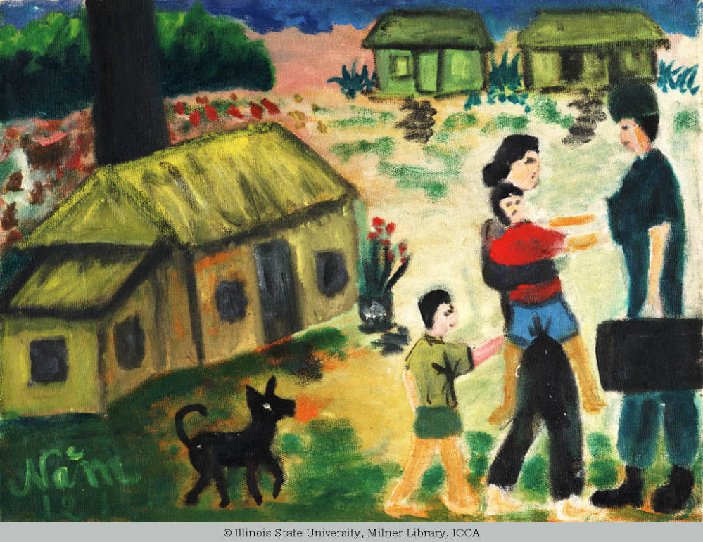
Title You have come
Artist Gender Boy
Artist Age 12
Location Vietnam
Date Created 1972 Material/Technique oil painting
Measurements 30.5 cm x 40.0 cm
This is the same subject matter, and probably the same artist as the image above. It has a similar style. Only in this storytelling, the whole family, including the children and the dog come out to meet the returning father. This is a very sweet social statement as well.
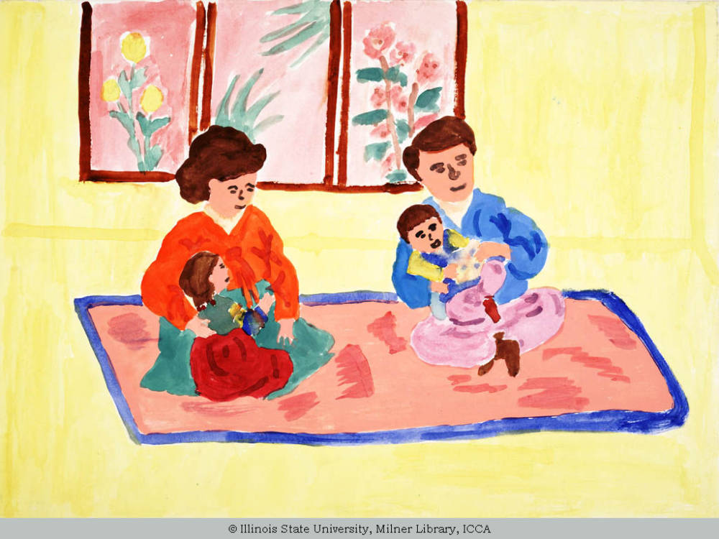
Title A Happy Family
Artist Gender Boy
Artist Age 15
Location Korea
Material/Technique water-based painting
Measurements 55.9 cm x 38.1 cm
Artist Comments A Happy Family. Mother and Father are caring for the little ones. They love each other.
This is an older artist, at age 15, who has managed to show perspective, good patterns, and attempts at foreshortening. He has used a bright and happy color palette to be in keeping with the mood and title intended. The way the parents are cradling the children shows a tenderness and caring, and the story is well articulated visually.
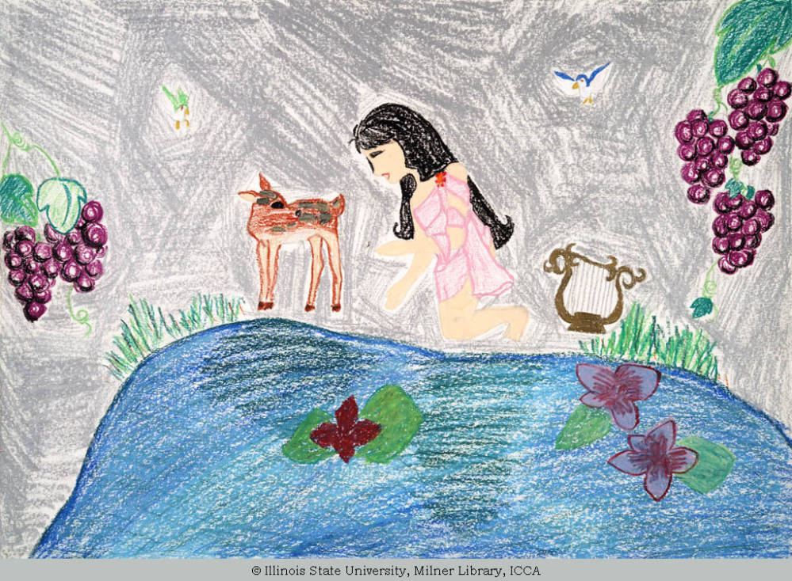
Title A Girl and a Baby Deer in the Wood
Artist Gender Girl
Artist Age 11
Location Japan
Material/Technique multi-colored drawing
Measurements 58.8 cm x 39.1 cm
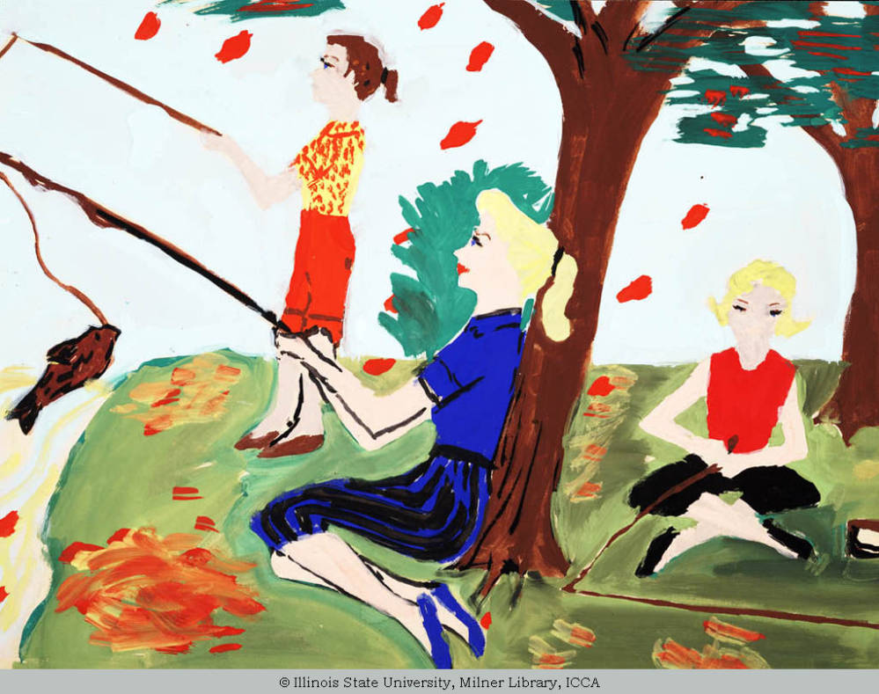
Title A Fishing We Will Go
Artist Gender Girl
Artist Age 13
Location Henderson, Texas, United States
Date Created 1960 Material/Technique water-based painting
Measurements 43.2 cm x 56.5 cm
This image caught my eye because it seemed to tell a story from another time, and reminded me of the “Fun With Dick and Jane” childhood readers I had as a kid. The hairstyles and clothing looked like it was from the past, even though all these exact styles (capris, ballet flats) have come back recently. What is interesting then is that the somewhat unexpected subject of the story is a Mother and two girls on a fishing trip. The painting is rendered with bold rich colors, and lush brush strokes. Great care was given to show the leaves falling from the trees and into piles to indicate the season.
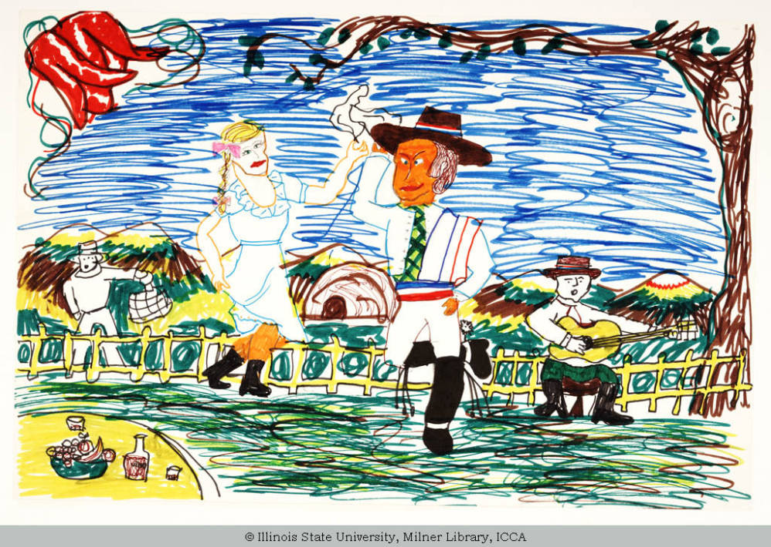
Title A Folkdance
Artist Gender Boy
Artist Age 10
Location Chile
Date Created 1974 Material/Technique multi-colored drawing
Measurements 45.5 cm x 30.0 cm
Artist Comments It is best danced showing its many nuances, in the Chilean rural areas where the cueca was born.
This amazing picture shows the artist’s love for his environment and culture in Chile. He depicts a special folk dance. Depth is shown with the table of food and wine in the lower foreground, and it was a good design decision to show only a portion, allowing only the curve of it in the corner. Next, in the middle ground the costumed dancers are lively with their feet kicked up in various positions as they move, while the musician plays in front of a carefully created fence. In the distance an onlooker watches from the fields, and the mountains are seen in the distance. To complete the composition a tree and branch create a frame on the top right quadrant which acts as a natural frame to keep your eye in the image. The thought and consideration, as well as the time, that must have gone into this is impressive.
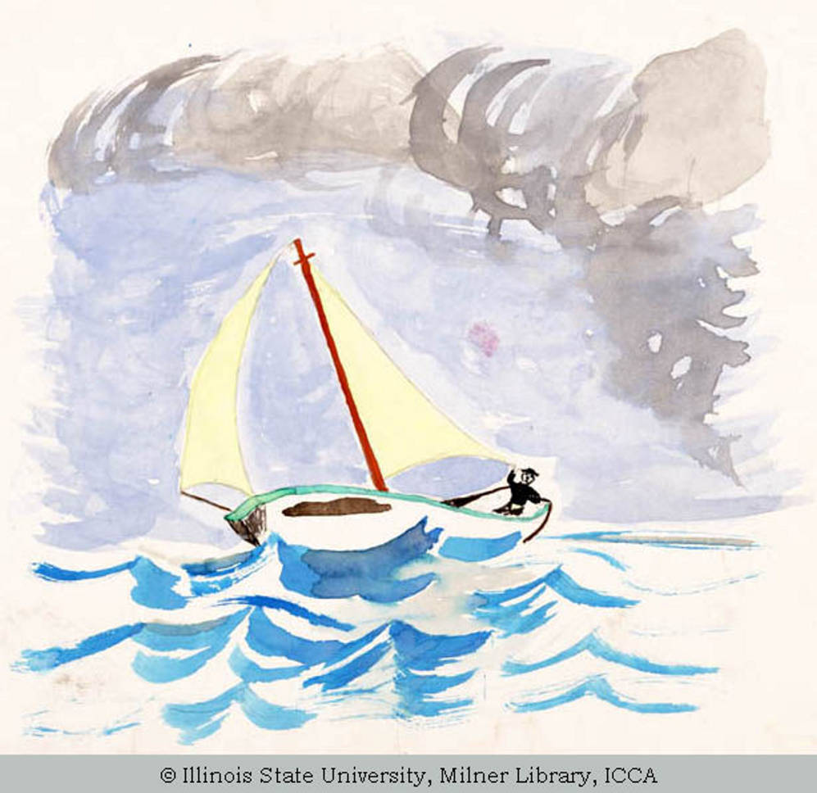
Title A Fishing Boat in Stormy Weather
Artist Gender Boy
Artist Age 12
Location Athens, Greece
Date Created 1970 Material/Technique water-based painting
Measurements 24.1 cm x 31.8 cm
This watercolor painting tells the story of a fishing boat at sea during a storm. The weather is depicted by the artist with the grey clouds and the choppy waves. This looks remarkably like Winslow Homer seascapes, especially the ones he did in Bermuda, so I suspect the artist may have been influenced by seeing his work. The artist showed great restraint for a child, to leave the white space on the paper and just indicate the waves with less strokes. That is difficult even for teens and adults to do.
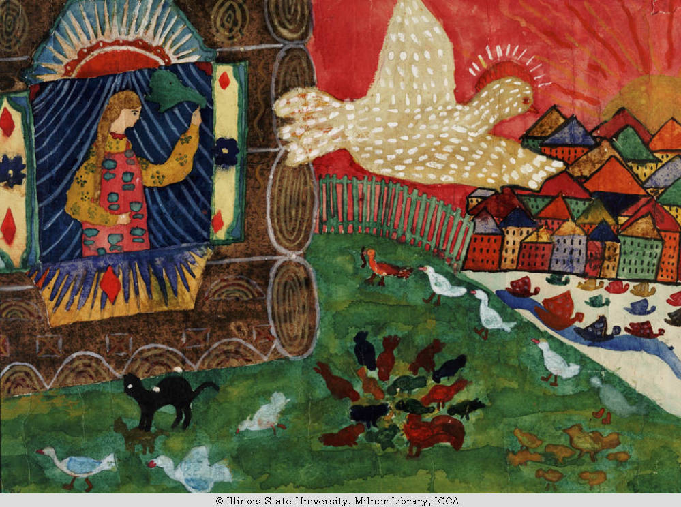
Title A Fairy Tale
Artist Gender Girl
Artist Age 11
Location Leningrad, Russia
Date Created 1970 Material/Technique watercolor painting
Measurements 53.3 cm x 43.2 cm
This captivating painting clearly shows the Russian cultural and artistic influence and environment. The palette of rich earth tones, and patterns, shows a female figure looking out of a window as a special looking bird flies over a lush countryside filled with animals. A town or city can be seen in the distance. It seems to be a perfect moment to illustrate from a fairy tale. I want to know the rest of the story.

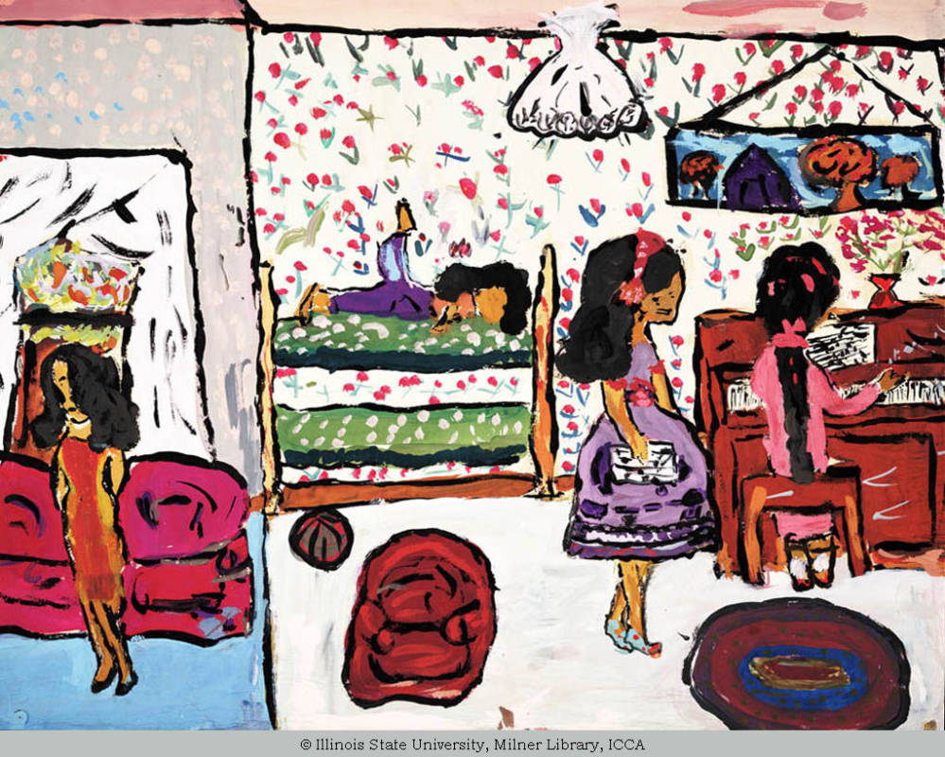
Title A Day at Home
Artist Gender Girl
Artist Age 11
Location Louisville, Kentucky, United States
Date Created 1960 Material/Technique water-based painting
Measurements 48.3 cm x 61.0 cm
This lively painting depicts a family at home. It appears to show a mother in the living room, and three sisters in an adjoining room. One seems to be reading or playing on the top bunk, one is playing the piano, and the other appears to be all dressed up to go out. This indicates that the child artist attempted to show personalities and interests or hobbies of each family member. A great deal of attention to detail is shown in the furnishing, curtains, and wallpaper in the backgrounds. I am struck by the fact that the artist noticed and included the top edge of the wall and part of the ceiling, as well as the chandelier. My guess is that the artist, who is an 11 year old girl, is the main subject of the painting. She has given the impression that the family is perhaps of another ethnicity than white, perhaps Hispanic, but I cannot say exactly.
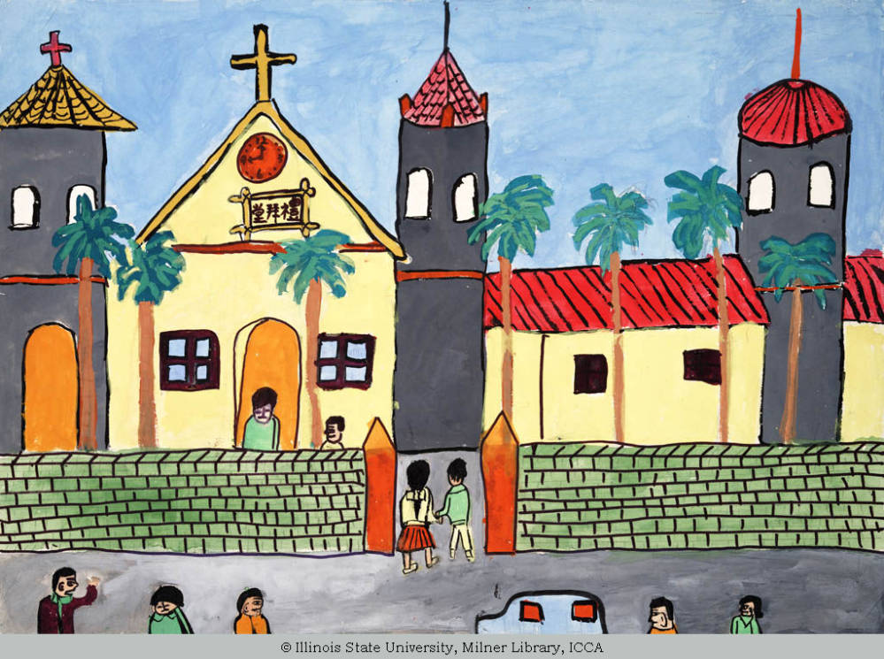
Title A Church
Artist Gender Girl
Artist Age 15
Location Taiwan
Date Created 1973 Material/Technique water-based painting
Measurements 39.0 cm x 54.5 cm

This image of a church is telling because it looks so stable and symmetrical and balanced. The strength is further enhanced by the strong wall, and the straight strong palm trees lined up in front. It is rendered in bright, happy colors, with people freely entering, and holding hands lovingly. The community seems to spill in and out indicating that the church is an integral part of this town or village in Taiwan. I think the people in the foreground on the lower portion of the image are interesting because they are not just a bunch of heads facing out. The figures are facing in a variety of directions, and positions, as if they are doing a lot of different things. I especially like the man on the bottom left. He could be raising his arm in anger, or to wave, or to high five someone. I would love to know the artist’s intention.
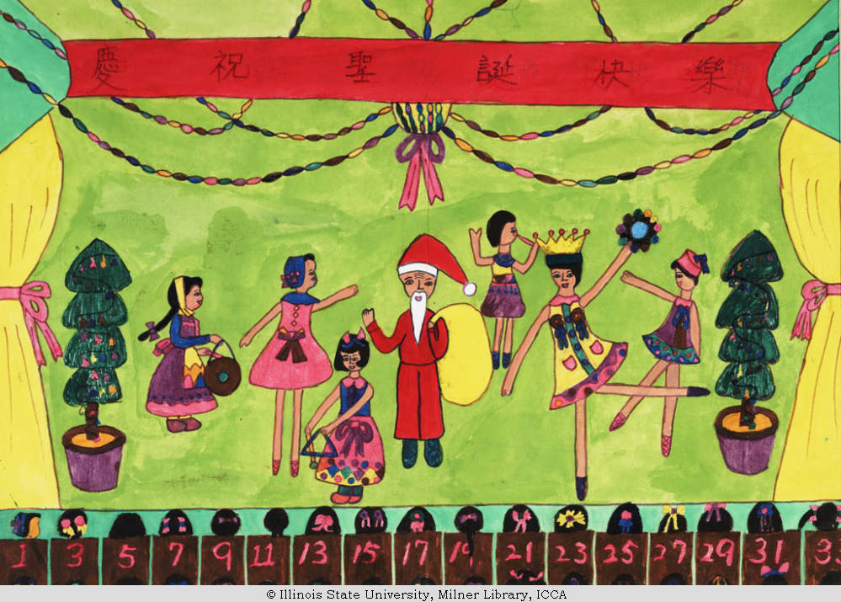
Title A Christmas Play
Artist Gender Girl
Artist Age 11
Location Taiwan
Date Created 1974 Material/Technique mixed media
Measurements 38.5 cm x 53.5 cm
This image of a Christmas play in Taiwan is reminiscent of the Peanuts cartoon “A Charlie Brown Christmas”. It seems influenced by America with Nutcracker ballerinas, Santa Clause and little costumed musicians, but that may just be my own cultural bias seeing it that way. But in any case, the artist carefully placed the curtains on the outer side portions to frame the image. However, the most ingenious part is at the bottom of the image, where the artist has included the backs of the heads of the audience members in their seats. Each little head has a different hair ribbon or bow. It is unclear why the seats are numbered, but the level of detail in this image is admirable.

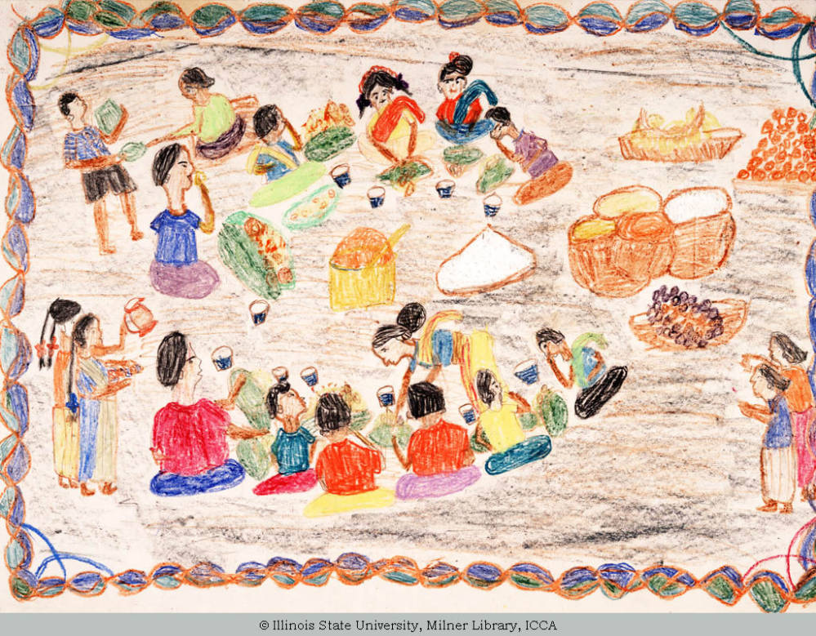
Title A Christmas Feast
Artist Gender Girl
Artist Age 12
Location India
Date Created 1974 Material/Technique multi-colored drawing
Measurements 51.0 cm x 38.0 cm
Artist Comments At Christmas mother will cook lots and lots of delicious food. Many friends will come for lunch on Christmas day and all will enjoy together the big Christmas feast.
An altogether different kind of Christmas celebration is depicted in this image which shows an Indian family enjoying a meal together. Figures are shown from various directions, and some new arrivals are entering from outside the image to join the feast with open arms. Some people seem to be eating, and some seem to be the servers, which could be family members or it could be a reference the the caste system in the Indian culture, especially in 1974 when this was made. A great level of care was taken to show each and every family member, details about their hair and clothing, and even each cup for the drink. A border was added around the image for further decorative detail.
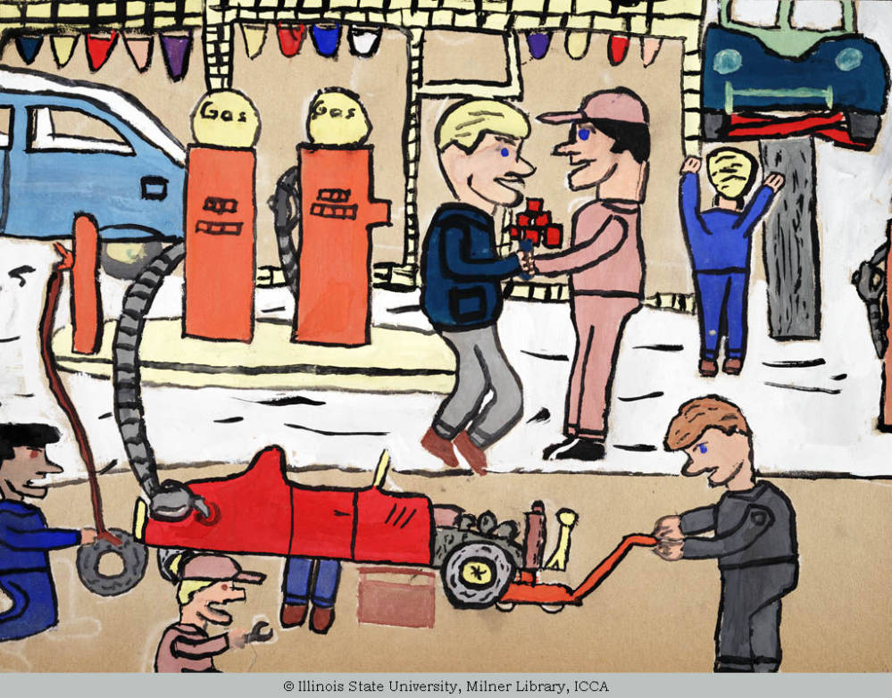
Title A Busy Station
Artist Gender Boy
Artist Age 11
Location Louisville, Kentucky, United States
Date Created 1960 Material/Technique water-based painting
Measurements 45.7 cm x 63.5 cm
This image is an example of the powerful observational skills of the child artist. Like many young male artists of this age, he is interested in cars, machines, and activities that men do. This visit to a mechanic’s shop/gas station shows people (no women) working on, and under cars, and even shaking hands are all depictions of the utmost masculine location. This artist showed depth by the use of overlapping objects. It is really an interesting composition with objects continuing off the page edge.

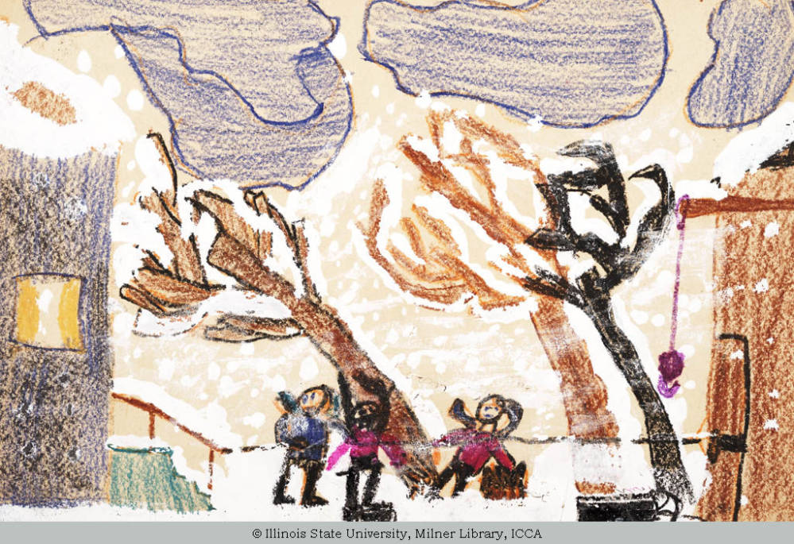
Title A Blizzard in the Country
Artist Gender Boy
Artist Age 12
Location Hammond, Indiana, United States
Date Created 1960 Material/Technique mixed media
Measurements 33.0 cm x 45.7 cm
This storytelling image depicts a wintery storm in progress, with the subjects leaning and having a difficult time walking in the wind. The trees lean also from the wind, and the weight of the snow. The snow in the air has been thoughtfully applied in a way that truly makes it seem gusty. The edges of the image are bordered by two homes, which helps to keep the eye centered in on the action.
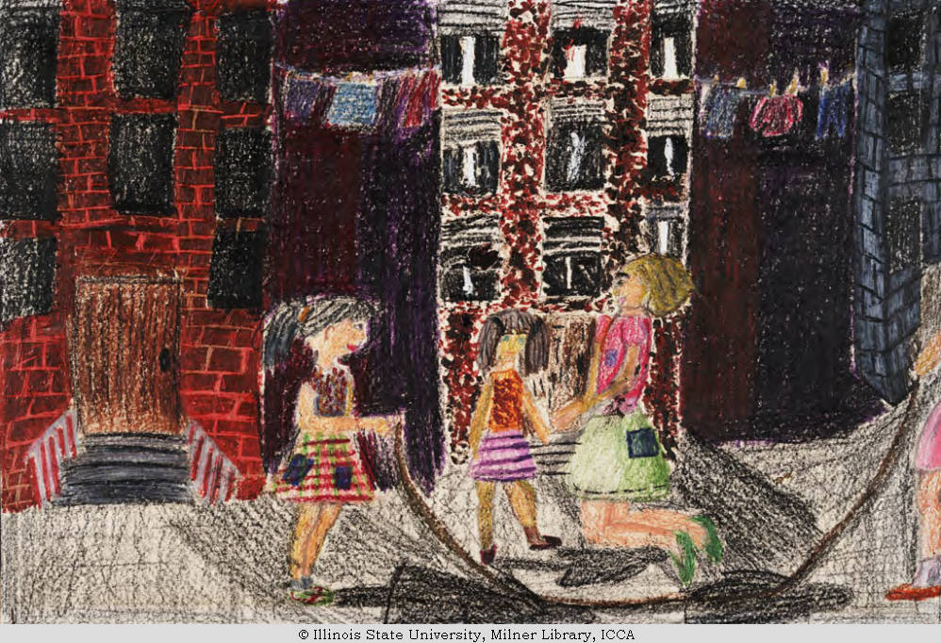

Title 76th Street
Artist Gender Girl
Artist Age 12
Location Topeka, Kansas, United States
Date Created 1967 Material/Technique multi-colored drawing
Measurements 27.9 cm x 43.8 cm
This female artist depicts a familiar street game of jump rope in an urban environment. Texture on the brick and architectural details, and clothing is outstanding. I particularly love the arching clothesline in the distance. In the foreground, the girls play and smile as they look on as someone has their turn.

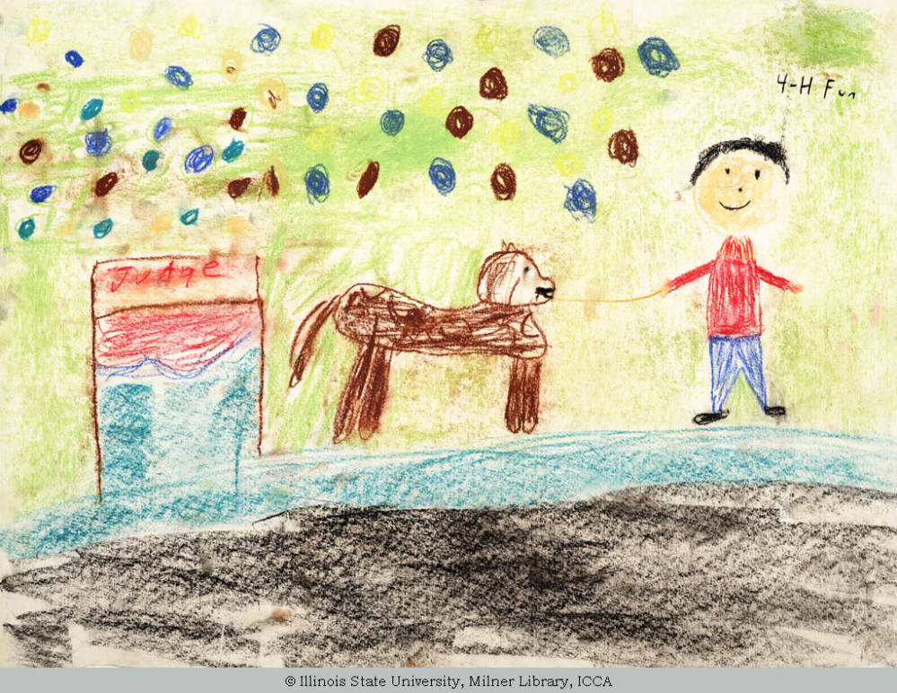
Title 4-H Fun
Artist Gender Boy
Artist Age 11
Location Broadwell, Illinois, United States
Date Created 1972 Measurements 45.7 cm x 61.0 cm
It looks like this image tells the story of an important moment in this child’s life when he “showed” an animal to be judged at a 4H event. It is a bit difficult to tell if the animal is a dog, or a farm animal since there are not a lot of details. However, it looks like a proud moment, and the artist has given the essence of that moment or memory visually, just as the Impressionists did. The audience in the background is shown in the symbolic oval for each of the faces, of various colors, rather than using Realism.
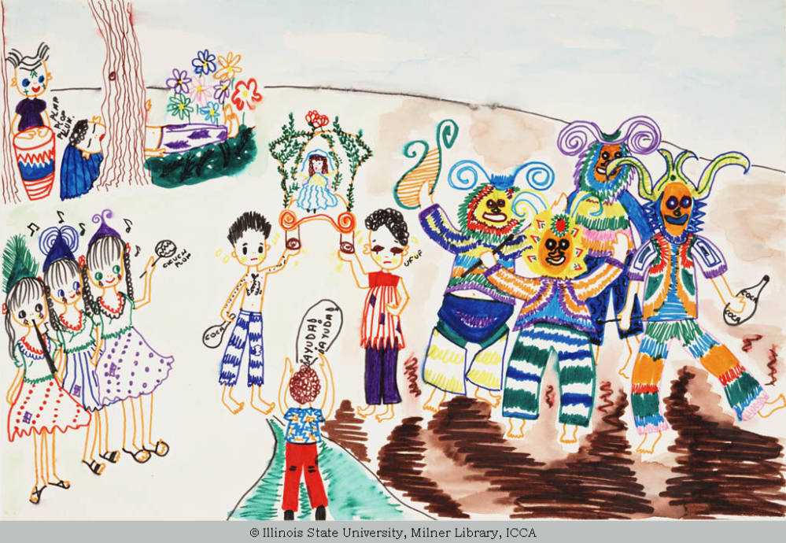
Title "La Tirana" Legend
Artist Gender Girl
Artist Age 12
Location Chile
Date Created 1974 Material/Technique multi-colored drawing
Measurements 45.5 cm x 30.5 cm
Artist Comments: In the north of Chile it is believed that there was a woman who converted to Christianity before her death. This event is commemorated for a entire day and the participants dance and sing. In order not to overly tire themselves and have a problem, they chew “COCA” this is a type of drug. It maintains their high spirits. They make the costumes and the masques throughout the year. Many foreigners come to this feast. Liceo “Los Andes”.
My comment: This artist depicts a religious ceremony from their culture in this rich storytelling image. The narrative shows five different segments of the story, that are happening simultaneously, and they each could stand as a separate vignette. The vibrant colors and the expressions on the faces go a long way in helping describe the lively and spirited event.

Conclusion: I truly enjoyed this look at children’s artwork. It is entertaining and extremely interesting to see how talented children artists are. It is also amazing to see how good they are at observation and drawing those realistic details that they observe.

